Security

🛡️ what is Security
# Source: AI Source: Provided by: [Data Path: Persons Table -> ID Column: 1, Name_En Column: Motasem Essam] -> From: [Chatgpt (GPT‑5 Mini)] on [1/20/2026]
Security refers to the practices, tools, and technologies used to protect systems, data, and services from threats. The goal is to prevent unauthorized access, data loss, manipulation, or service disruptions.

What is unauthorized access, data breaches, defacement, and service disruptions.

1. 🔐 Unauthorized Access
# Source: AI Source: Provided by: [Data Path: Persons Table -> ID Column: 1, Name_En Column: Motasem Essam] -> From: [Chatgpt (GPT‑5 Mini)] on [1/20/2026]
What it is:
When someone gains access to a system, account, or resource without permission.
Example:
- A hacker cracks a weak admin password for a corporate network.
- Exploiting improper access controls to view confidential company files.
Why it’s dangerous:
- Sensitive data can be stolen, modified, or deleted.
- Attackers can impersonate users or escalate privileges.
Prevention:
- Strong authentication (password policies, 2FA)
- Role-based access control
- Secure session management

2. 🛡️ Data Breaches
# Source: AI Source: Provided by: [Data Path: Persons Table -> ID Column: 1, Name_En Column: Motasem Essam] -> From: [Chatgpt (GPT‑5 Mini)] on [1/20/2026]
What it is:
An incident where confidential or protected data is accessed, stolen, or disclosed without authorization.
Example:
- Employee records or financial information leaked from a database.
- Cloud storage misconfigured, exposing sensitive files publicly.
Why it’s dangerous:
- Legal and regulatory consequences (e.g., GDPR fines)
- Loss of trust in the organization
Prevention:
- Encrypt data at rest and in transit
- Implement strict access controls
- Regular security audits and monitoring

3. 🎨 System Defacement / Tampering
# Source: AI Source: Provided by: [Data Path: Persons Table -> ID Column: 1, Name_En Column: Motasem Essam] -> From: [Chatgpt (GPT‑5 Mini)] on [1/20/2026]
What it is:
When an attacker alters the appearance, content, or configuration of a system.
Example:
- Company intranet shows malicious or misleading messages.
- Critical system files modified to disrupt operations.
Why it’s dangerous:
- Damages reputation
- Reduces trust among users or employees
- Indicates deeper system compromise
Prevention:
- Secure administrative interfaces
- Keep software and systems updated
- Monitor file integrity

4. 🚫 Service Disruptions
# Source: AI Source: Provided by: [Data Path: Persons Table -> ID Column: 1, Name_En Column: Motasem Essam] -> From: [Chatgpt (GPT‑5 Mini)] on [1/20/2026]
What it is:
Attacks or failures that make a system, application, or service slow, unreliable, or unavailable.
Example:
- Denial-of-service (DoS) attacks overwhelm a server.
- Hardware failure or unhandled exceptions crash critical applications.
Why it’s dangerous:
- Operational downtime
- Loss of productivity or revenue
- Frustration and dissatisfaction for users
Prevention:
- Redundant systems and failover strategies
- Traffic filtering and load balancing
- Incident response planning and monitoring

🔐 Key Goals of Security
# Source: AI Source: Provided by: [Data Path: Persons Table -> ID Column: 1, Name_En Column: Motasem Essam] -> From: [Chatgpt (GPT‑5 Mini)] on [1/20/2026]
- Confidentiality – Keep information private.
- Integrity – Ensure data cannot be tampered with.
- Availability – Keep systems and services accessible when needed.
- Authentication – Verify the identity of users or devices.
- Authorization – Ensure only allowed actions can be performed.

🧰 Common Threats
# Source: AI Source: Provided by: [Data Path: Persons Table -> ID Column: 1, Name_En Column: Motasem Essam] -> From: [Chatgpt (GPT‑5 Mini)] on [1/20/2026]
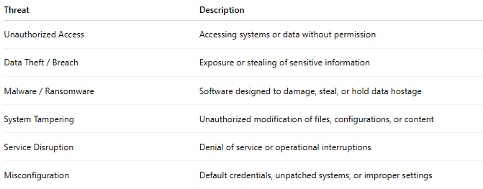
Threat | Description
Unauthorized Access | Accessing systems or data without permission
Data Theft / Breach | Exposure or stealing of sensitive information
Malware / Ransomware | Software designed to damage, steal, or hold data hostage
System Tampering | Unauthorized modification of files, configurations, or content
Service Disruption | Denial of service or operational interruptions
Misconfiguration | Default credentials, unpatched systems, or improper settings

🔑 Best Practices
# Source: AI Source: Provided by: [Data Path: Persons Table -> ID Column: 1, Name_En Column: Motasem Essam] -> From: [Chatgpt (GPT‑5 Mini)] on [1/20/2026]
- Authentication & Access Control – Strong passwords, 2FA, and role-based access.
- Data Protection – Encrypt sensitive data and back it up regularly.
- Patch & Update – Keep systems, software, and devices current.
- Monitoring & Auditing – Track access and detect anomalies.
- Incident Response – Plan for attacks, breaches, and outages.
- Security Awareness – Train staff on risks and safe practices.

✅ Summary
# Source: AI Source: Provided by: [Data Path: Persons Table -> ID Column: 1, Name_En Column: Motasem Essam] -> From: [Chatgpt (GPT‑5 Mini)] on [1/20/2026]
Security is about protecting systems, data, and services from threats. It requires a combination of policies, practices, technology, and vigilance to ensure confidentiality, integrity, and availability.

